Development of a Multi-Criteria Decision Support System for the Expansion of the Tesla Supercharger Network

Polytechnic University of Catalonia

MAI-MCDSS

June 6, 2016

Cole MacLean

# 1.0 Introduction

With the recent unveiling of Tesla's Model 3 and pre-orders approaching 400,000, the internet has been buzzing with Tesla discussions and analysis. One of Tesla's key differentiators from other mass market Electric Vehicles (EVs) is its Super Charger (SC) network that provides 170 miles of range in [30 minutes.](https://www.teslamotors.com/supercharger) With Elon Musk stating plans to double the size of the SC network by the end of 2017, a large amount of planning, resources and investment are being allocated to this network expansion.

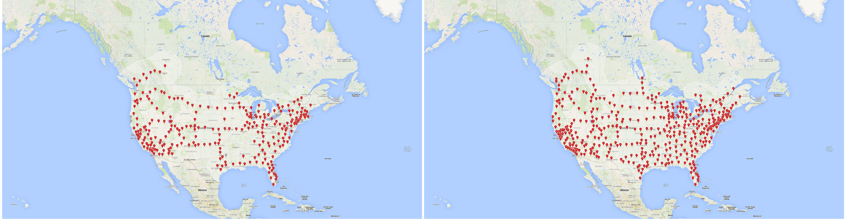

Figure 1: Tesla Supercharger 2016 Planned Expansion

## 1.1 Beyond 2016

Although the Model 3 will be a cheaper, mass market vehicle, the base model is still projected to have a hefty price tag of 35,000 USD. Most customers are also likely to add on optional packages to enhance the capabilities of their Model 3's. With these additions, the average Model 3 price is estimated to be [42,000 USD](http://www.hybridcars.com/musk-model-3-price-will-probably-average-42000-with-options/), which will be one of the largest purchases people make in their lifetimes. A financial decision of this magnitude deserves careful consideration, and an important aspect many potential customers will be considering is their ability to access the Tesla Supercharger network. Although detailed plans about Tesla's Supercharger network expansion are not currently available, details about the current network and its historical growth may provide clues about what we can expect for its future.

## 1.2 MCDA Approach

Using existing data about the current network, we can use utilize MCDA methods to develop a Decision Maker (DM) preference model to recommend future Supercharger locations. Using attributes of the network, and computing the performance value for each expansion alternative based on these attributes, we can develop a selection model as a decision support system.

## 1.3 Data Sources and Model

**Data Sources**

The collected data has been structure into a NetworkX Graph, which is made up of nested dictionaries. There are 4 main data sources that were used to build the data structure:

1. [Teslarati's Super Charger Map](http://www.teslarati.com/interactive-tesla-supercharger-map/) - Used as the source of existing Tesla Superchargers with GPS coordinates
2. [Google Maps Directions API](https://developers.google.com/maps/documentation/directions/) - Used to obtain driving distances between each SC
3. [Tesla Info](https://www.teslamotors.com/findus/location/supercharger/chamberybarberazsupercharger) - Information about amenities at a specific SC (ie. Chargers, Restaurants, WiFi, etc.)
4. [Population Data](http://ezlocal.com/blog/post/Top-5000-US-Cities-by-Population.aspx) - List of cities and corresponding population.

Both Nodes and Edges have nested data dictionaries containing their respective datum from the above datasets, with example structures displayed below.

**Notes**

1. Nodes are keyed on the geohash of the GPS coordinates given for each SC from teslaraties dataset
2. The weight of each edge is the normalized aggregated population of the connected nodes - (pop_node_1 + pop_node_2)/(total_population_dataset) where total_population_dataset = 200,087,175

**Node Data Dictionary**

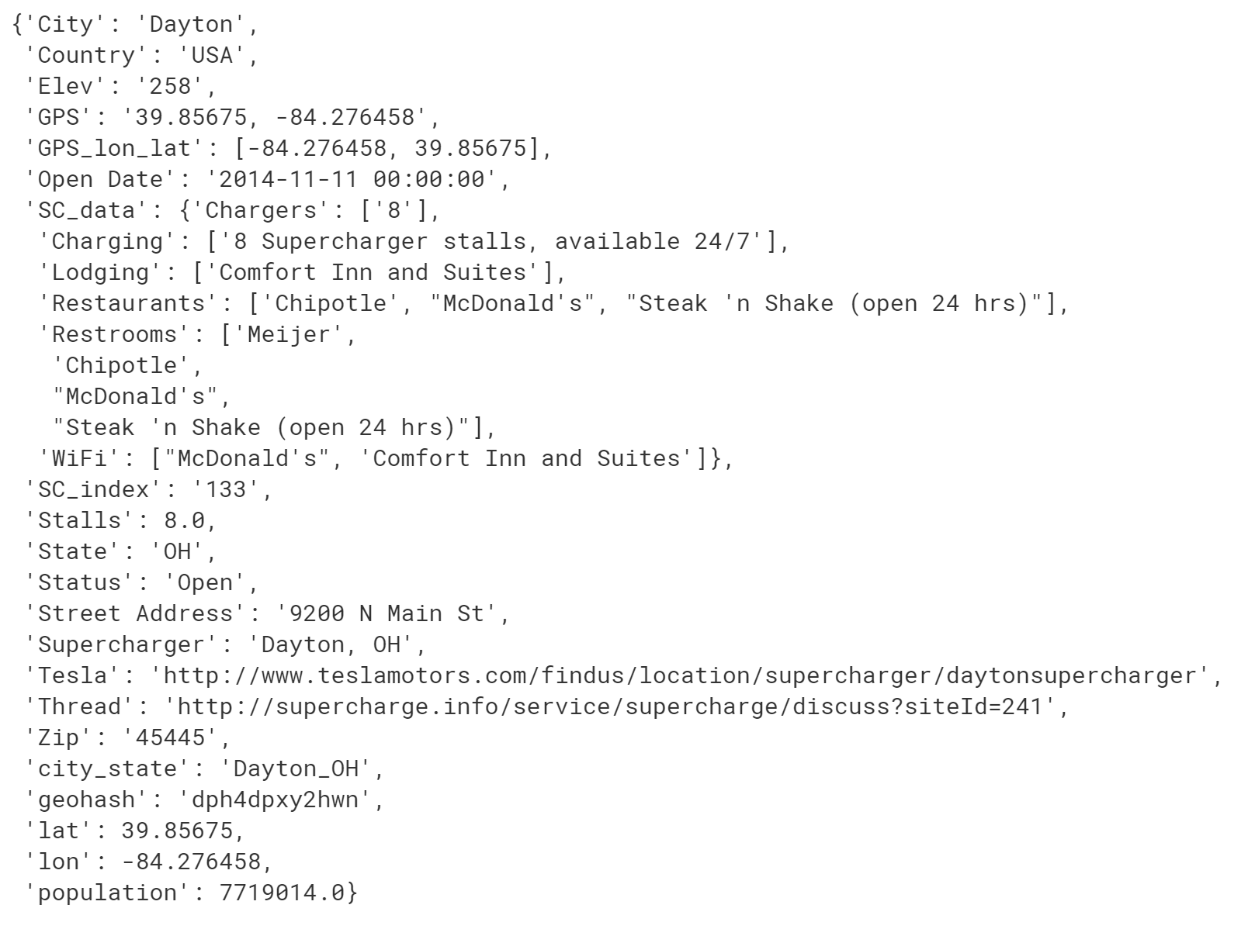

**Edge Data Dictionary**

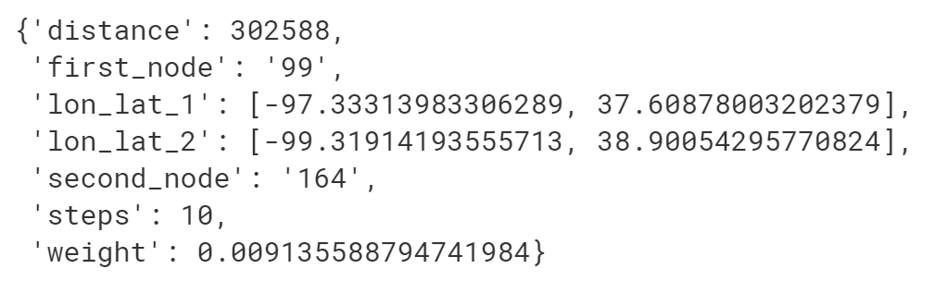

## 2.0 Multi-Attribute Utility Theory (MAUT)

Using utility theory, we can attempt to discover a cost function using the attributes of the network to calculate the expansion utility of a potential expansion location. We can then optimize this function by appropriately weighting each attribute such that the network generated from this function closely matches the expected network of a decision maker.

## 2.1 Network Attributes

Reviewing the historical growth of the network, we can conceptualize the characteristics of an ideal Super Charger network. These characteristics are:

1. Breadth - the geographic coverage area of the network defined as the area of the ellipse formed by the haversine distances of the network's furthest North and South and East and West connected Super Chargers.

2. Penetration - the % of the population represented in the network defined as: (net_pop/tot_pop)

3. Connectivity - the % of population represented in the main connected sub graph of the network

4. Robustness - the number of SCs that can be offline before the network becomes disconnected defined with networkx's node_connectivity algorithm

5. Efficiency - the avg effective travel distance of a trip using a SC connection, defined by the sqrt(Breadth/pi) divided by networkx's average_shortest_path_length algorithm

6. Density - the average number of SCs per km^2 in the network defined as Super Charger count of network Breadth

These characteristics are analyzed through the evolution of the current Super Charger network and represented in figure 2.

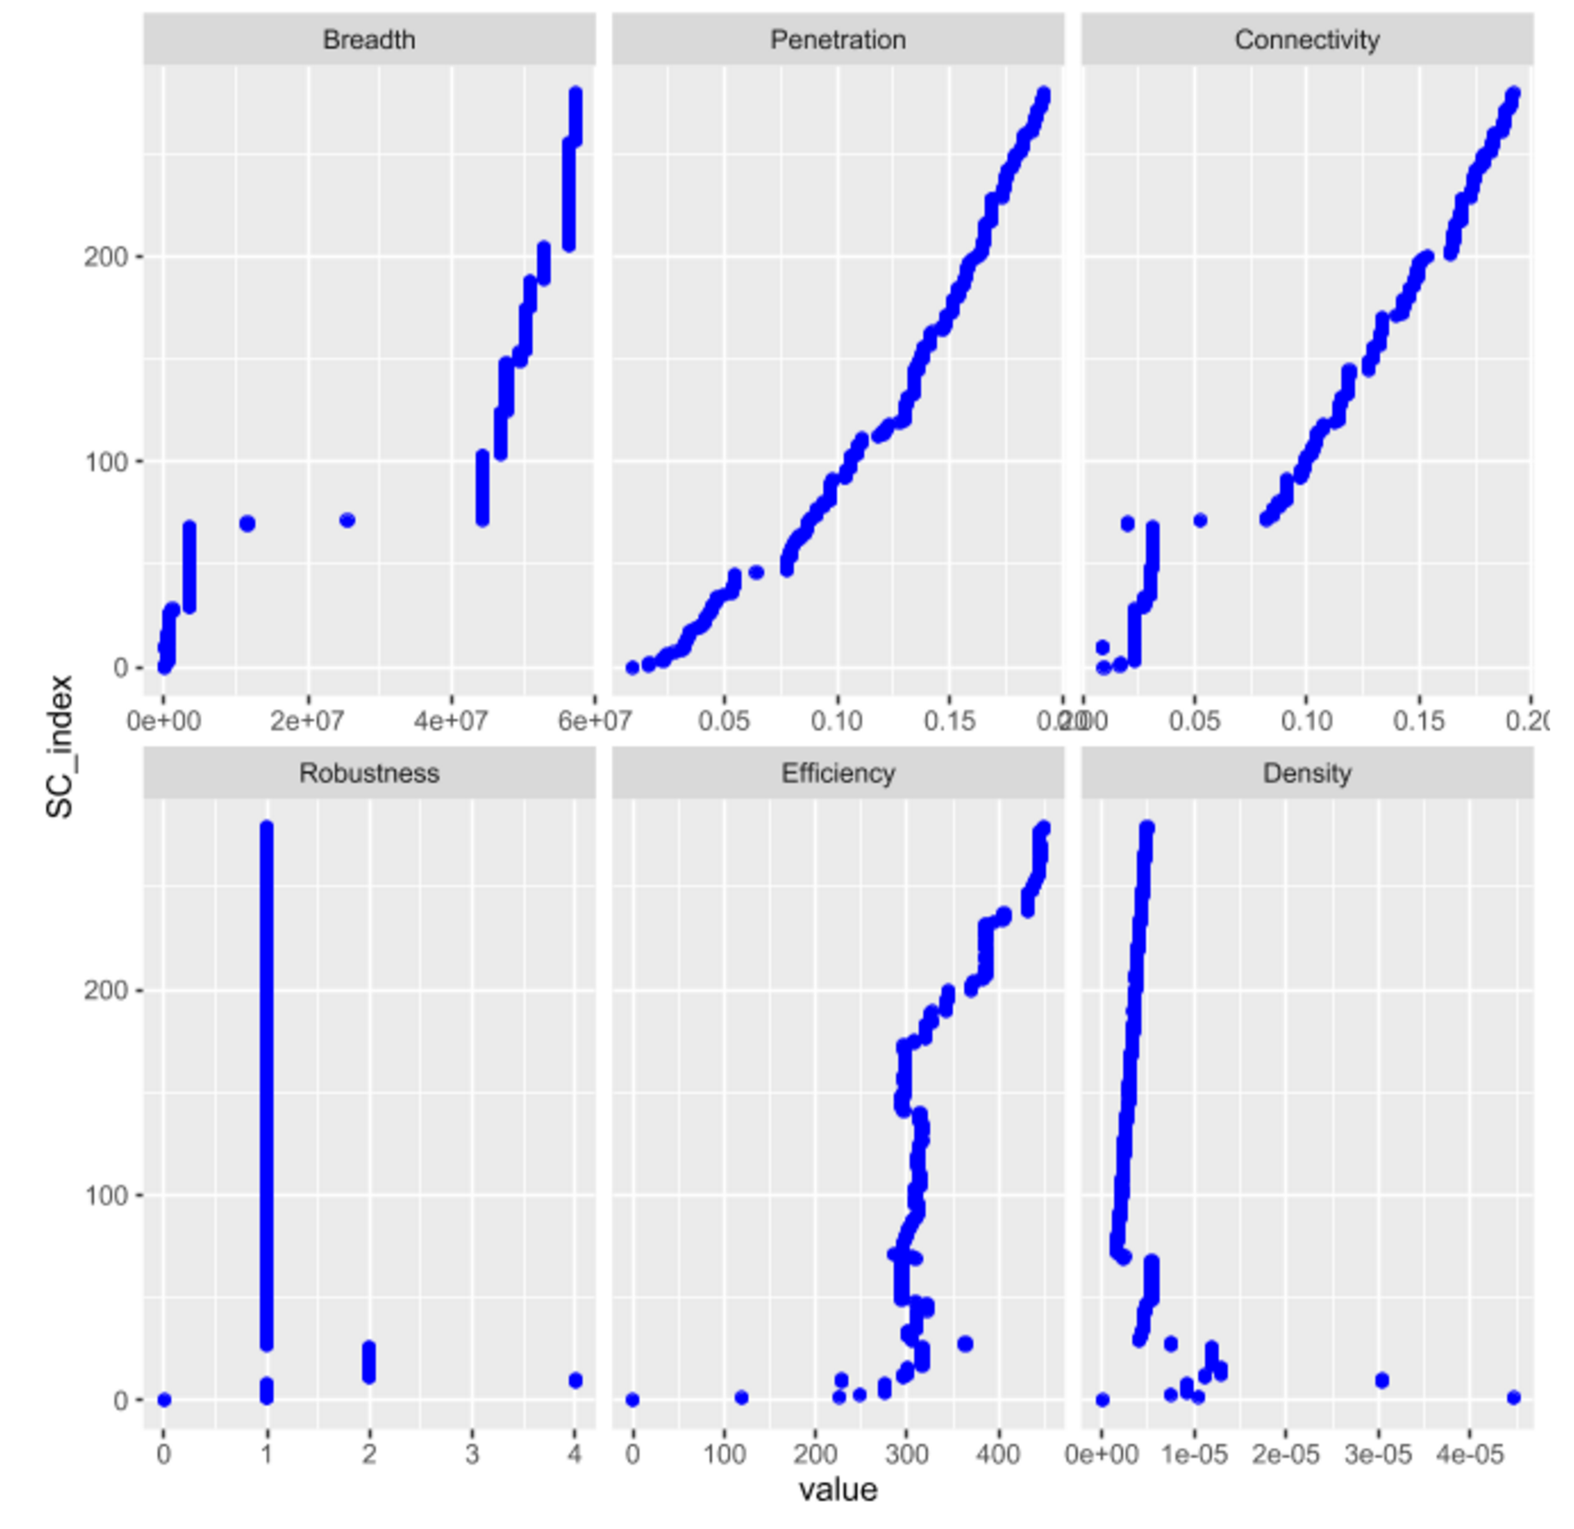

Figure 2- Supercharger Network Characteristic Growth

These plots provide insight into the characteristic contributions to the network the addition of a SC provides. Most measures appear to be being maximized, but at much different rates per SC addition. Penetration and Connectivity appear to have linear or sub linear growth that may further decelerate forming a logarithmic trend, as the high population density locations are selected and each additional Super Charger adds continually less new population representation to the network. Breadth also appears to have a linear growth profile in the network maturation stage of the network but appears to be slowing down through the current equilibrium stage of the network. It's apparent that increasing the Breadth is a desirable characteristic of adding a new SC, but does not appear to be the dominant deciding factor on a SC addition. Density also presents a clean linear trend through the maturation and equilibrium growth stage of the network, without any indication of decelerating. It is intuitive that as the network expands, and population representation approaches 100%, a larger focus on network Density will be used to determine the addition of a future Super Charger. This is also apparent in the more sporadic, but still increasing Efficiency plot, which was fairly flat through the network maturation growth stage, but has accelerated through the equilibrium growth stage of the network. The only characteristic that does not appear to be maximized is the networks robustness, which indicates that, on average, the removal of a single SC in the network can cause SCs to become disconnected from the rest of the network. Again, this is somewhat intuitive, as although having a robust network is desirable, this is a characteristic of very mature networks where building in redundancy is more important that gaining fractionally more network coverage. This information should be useful in building a network growth model that will need to accurately represent these growth characteristics.

## 2.2 Utility Function and Weights

In order to correctly represent the preference model, appropriate weights need to be assigned to each network attribute. From reviewing the historical network growth, and the above graphs, we can estimate good value for attribute weights. With these weights, the final utility function is defined in equation 1. Attribute values are normalized by each attributes standard deviation.

U(SC) = 0.1*Breadth + 0.25*Connectivity + 0.05*Robustness + 0.4*Efficiency + 0.2*Density

Note: Penetration is not included in the utility function, as penetration and connectivity are dependent on each other and would cause interactions in the model. Connectivity is used to cover both attributes.

# 3.0 Set of Alternatives

Before applying the predictive model, we first have to consider all of the potential locations we can build a Supercharger. We could simply consider ever city in all of North America, but that would be many options that may be difficult to choose from. Instead, we can define a "Major City" as any city with a population greater than 15,000 people and only consider those as potential expansion locations. We can also assume that we do not want to build Superchargers in cities that already have Superchargers, or are very close to other cities with them. With these filters, we can build a model to recommend the best locations to build Superchargers from this list of potential locations.

The graphic below visualizes the filtering process. The red nodes are SCs currently part of the network, the yellow nodes are potential expansion locations based on the filters, and blue nodes are major cities filtered out of the search space. The green boxes are the regions that each Supercharger is able to be connected to.

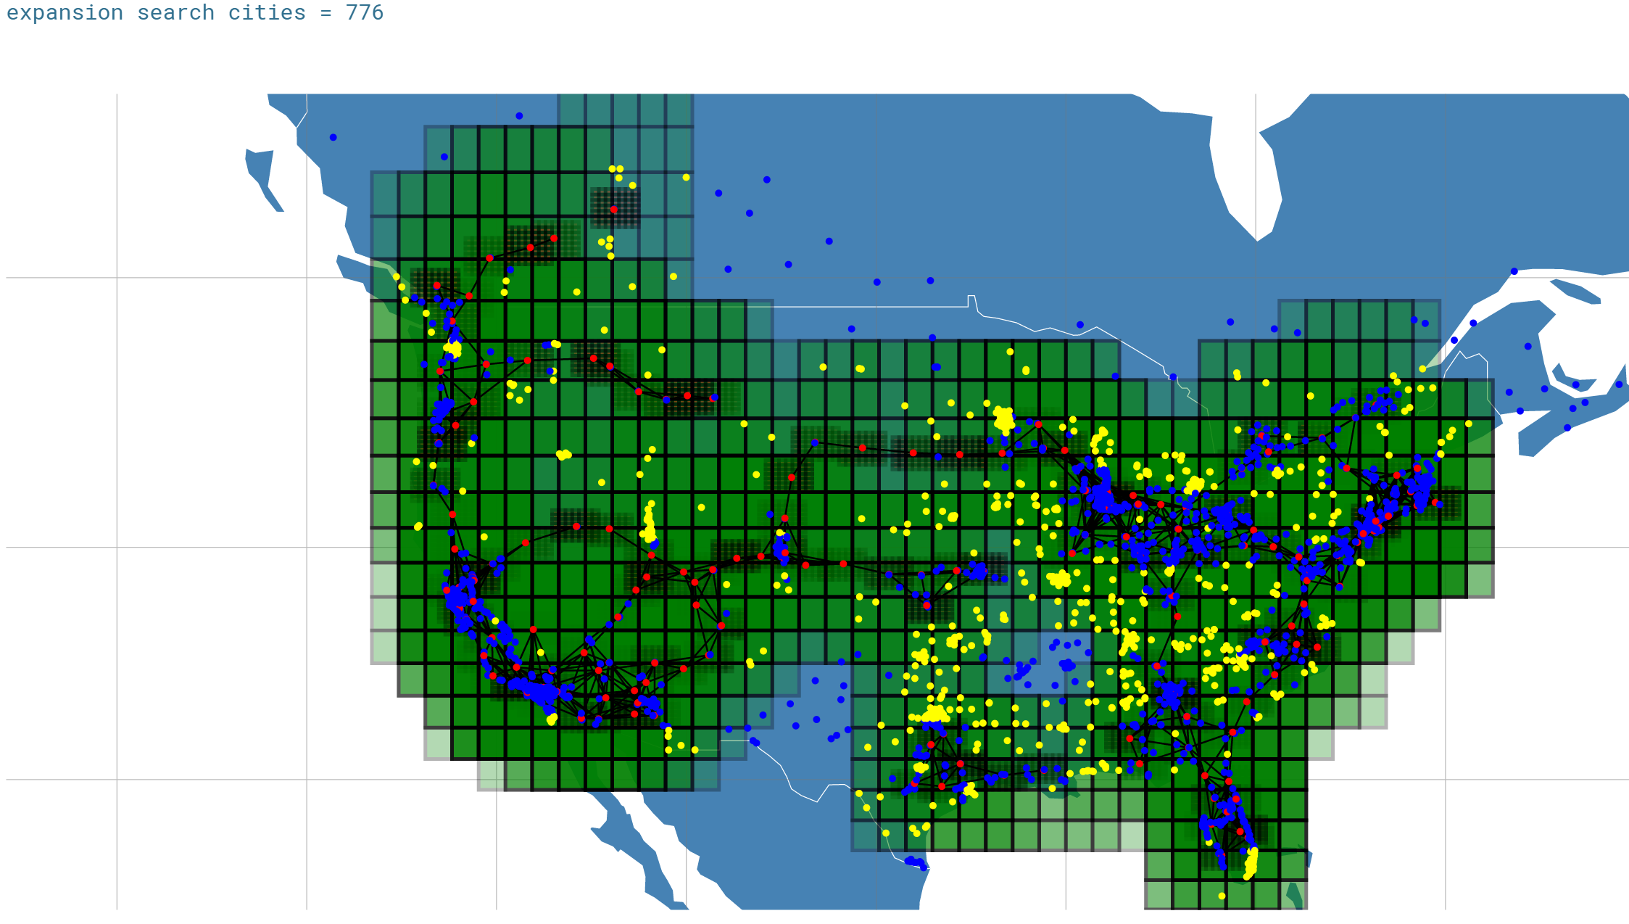

Figure 3 - Potential Alternative Search Space

# 4.0 Final Results

With the utility function and set of alternatives defined, we can apply the model to grow the network one Supercharger at a time. After adding 200 Superchargers onto the current 280 Superchargers, the final network with 480 Superchargers is represented in Figure 4.

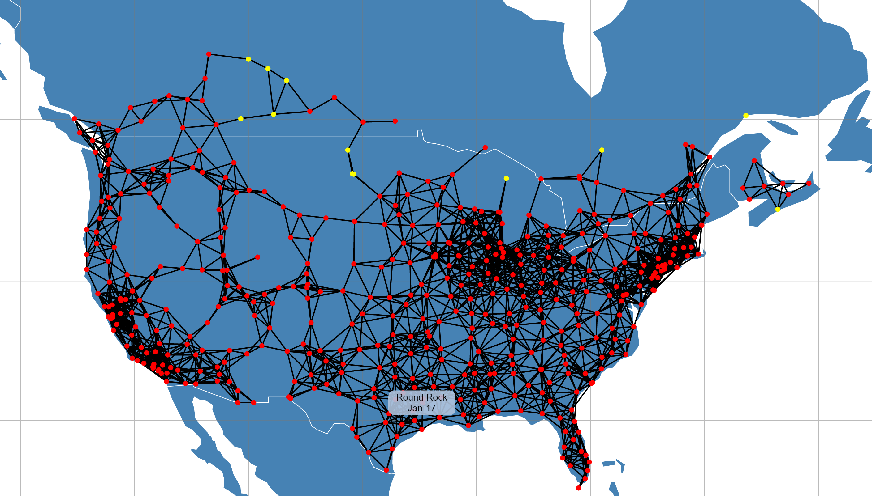

Figure 4 - Final MCDA Model Results

The final results of the MCDA model appear to be successful, in developing an expansive and robust Supercharger network.

An interactive visualization of the final model can be viewed [here](http://cole-maclean.github.io/MAI-CN/).

# 5.0 Conclusions

The MUAT technique of MCDA provides a flexible tool for modeling complex decision making problems. The above analysis was able to utilize this technique to build a decision support system in expanding a complex infrastructure, and was able to produce reasonable results

## 5.1 Future Work

**Additional Modeling Techniques**  
Here we've explored the MUAT technique for modeling this decision process, but there are other techniques that exist which may provide better results. Two that come to mind are MCDA pairwise preference modeling and Complex Network modeling. In MCDA, there exists techniques of pairwise preference modeling, where given a set of pairs of alternatives with their attribute values and the preferred alternative labelled, it is possible to learn the preference model of a decision maker. [This](http://link.springer.com/article/10.1007/s10994-013-5365-4) paper provides a very good overview of this technique and provides a comparison to the Machine Learning classification technique. Alternatively, techniques for modeling complex networks that take into account node attribute value exist, such as the [Multiplicative Attribute Graph Model](https://cs.stanford.edu/people/jure/pubs/mag-im12.pdf). It would be interesting to compare the results of these techniques with the ones utilized here.

**Multi-node Growth Modeling**  
The current model is only able to model the decision of adding a single Supercharger at each step in network growth, but this is not a realistic model of the actual decision process. Tesla will consider the effects of added multiple Superchargers in their plans, as looking two or three SC in the future can build a bridge in the network that increases the networks utility far more than adding 3 locally maximal separate SCs. This type of future planning increases the search space of potential networks exponentially and becomes analogous to the next move search space computational problem tackled by google's AlphaGo team. Perhaps techniques developed there could be utilized in these type of decision processes.

**Incorporate More Data**  
The data model and analysis here provide a foundation for developing future models that can incorporate more and better discriminating datasets to build a better predictive growth model of the Tesla Supercharger Network. For now, I hope others have fun exploring this analysis and attempting to predict when their city might be getting a SC.